**Practical no-4**

**Write a PL/SQL Block of code for: a) Borrower(Rollin, Name, DateofIssue, NameofBook, Status) b) Fine(Roll_no, Date, Amt) Calculate the fine for a book by accessing the borrower’s information.**

**Create table -**

create table borrower(

rollno number(5),

name varchar2(20),

dateofissue date,

nameofbook varchar2(20),

status varchar2(20)

);

-------------------------------

insert into borrower values(1,'Sanket','20-Sep-2022','PLSQL','I');

insert into borrower values(2,'Mayur','30-Aug-2022','MYSQl','I');

insert into borrower values(6,'Prachi','10-Sep-2022','DBMS','R');

insert into borrower values(3,'Abhi','30-Jul-2022','TOC','I');

insert into borrower values(4,'Aditya','05-Aug-2022','CNS','R');

insert into borrower values(5,'Aditi','25-Sep-2022','SPOS','I');

-------------------------------

Select * from borrower;

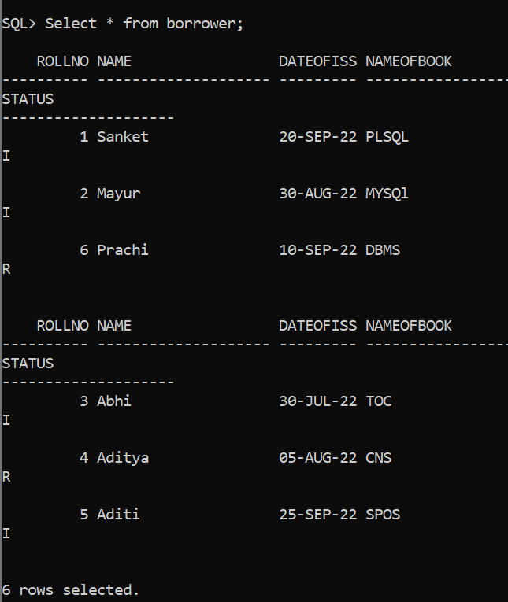

**create table-**

create table fine(

rno number(10),

sdate date,

fineamount number(20)

);

Set Serveroutput on;

**Create Procedure –**

declare

roll number;

name varchar(20);

doissue DATE;

doreturn DATE;

name_book varchar(20);

status varchar(3);

day number(3);

fine_amount number(10):=0;

ex_invalid_id EXCEPTION;

BEGIN

roll:=&roll;

name_book := '&name_book';

IF roll <= 0 THEN

RAISE ex_invalid_id;

END IF;

select dateofissue INTO doissue from borrower where rollno=roll;

doreturn:=SYSDATE;

day:=SYSDATE-doissue;

IF(status!= 'R' and day>=15 AND day<=30 ) THEN

fine_amount:=day*5;

dbms_output.put_line('Fine Amount = '||fine_amount);

ELSIF (status!='R' AND day>30) THEN

fine_amount:=day*50;

dbms_output.put_line('Fine Amount = '||fine_amount);

ELSE

dbms_output.put_line('There is No Fine');

END IF;

insert into fine(rno,sdate,fineamount) values(roll,SYSDATE,fine_amount);

UPDATE borrower SET Status='R' WHERE RollNo=roll;

EXCEPTION

WHEN ex_invalid_id THEN

dbms_output.put_line('Roll Number must be greater than zero!');

END;

/

-----------------------------------

select * from fine;